Seminar summery report
We did two seminars under the title “new Attendance system” for all staff ( full time and part time) in faculty of Administrative and Financial sciences as follow:
- Tuesday 16/10/2018 at 1:30
- Thursday 18/10/2018 at 1:30
The seminar addressed the following topics, supported by practical examples and I will summarize it in the following steps:
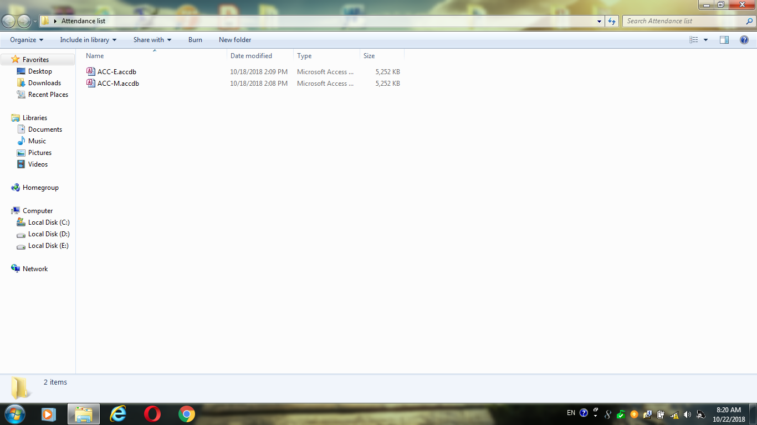
- To start up the program the teacher should have a copy of this program from the coordinator of department where he/she lecturing which contain two database for morning classes and evening classes, so he/she select one of them according the time of the lecture as shown in figure 1.

Figure 1
For example in Accounting Department Acc-E for evening classes and Acc-M for morning classes .
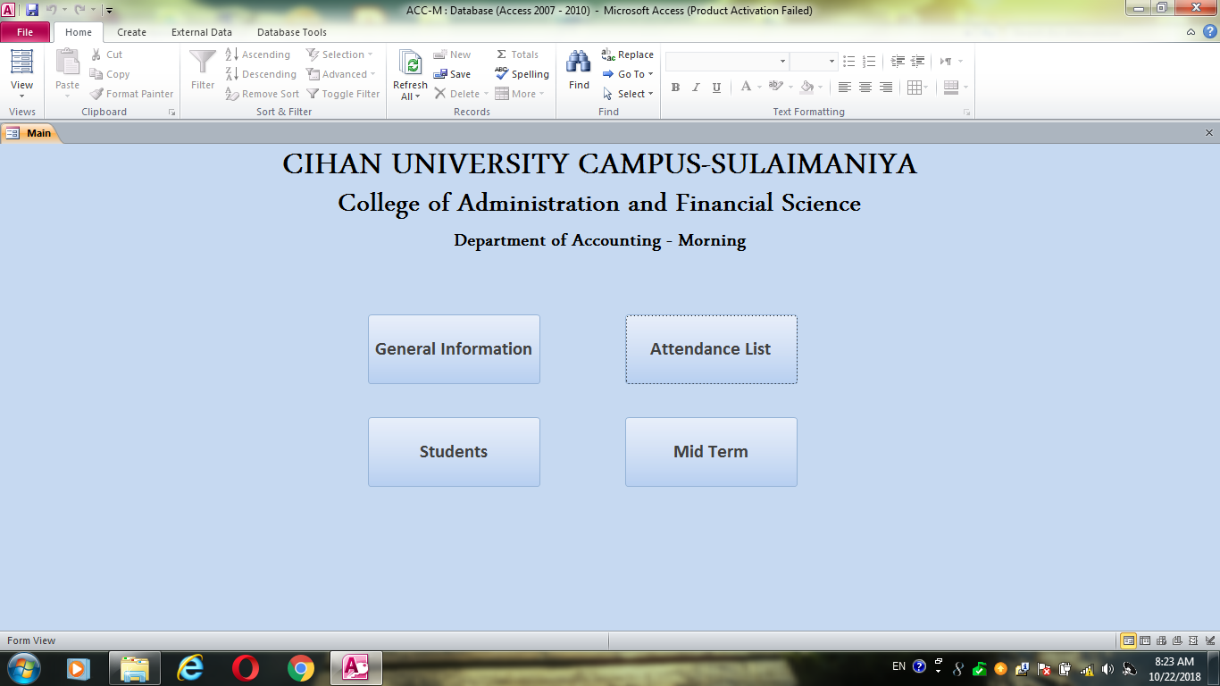
- To startup the program just click on one of the them you will get the main interface of the program as shown in figure 2.
Figure 2
Its friendly interface and the user be able to make a good deal with.
In this interface which contain the following tabs ( General Information , Attendance list, Student , and Mid Term)
the teacher should select first “general Information “ first, which contain many tabs as shown in figure 3.

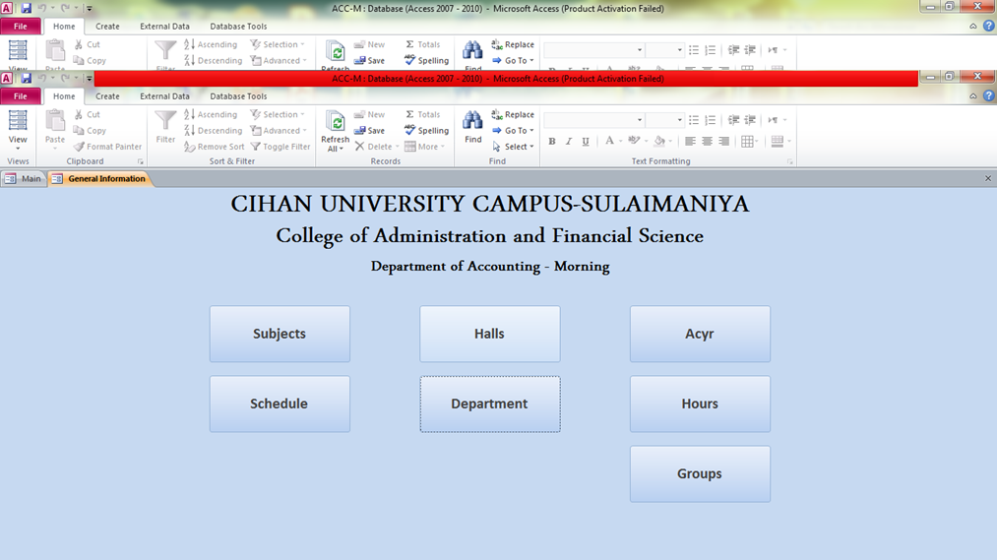

Figure 3
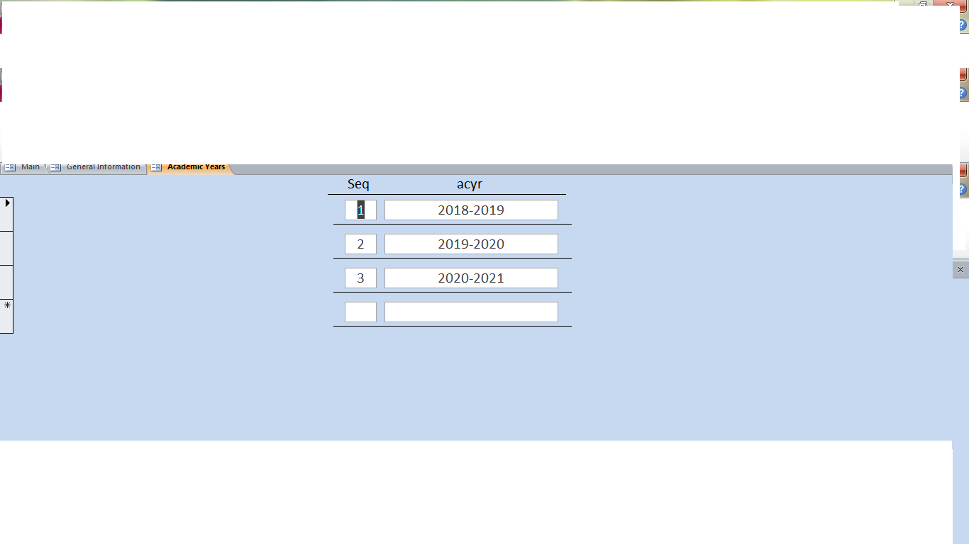
Which contain many tabs, let us start with first one “Acyr” this tab refer to Academic year when the teacher click on this tab he will get the new page as shown in figure 4

Figure 4
Here you can see that the academic year was already defined as shown .
- The techer then go for next tab which is “Hours” as shown in figure 5

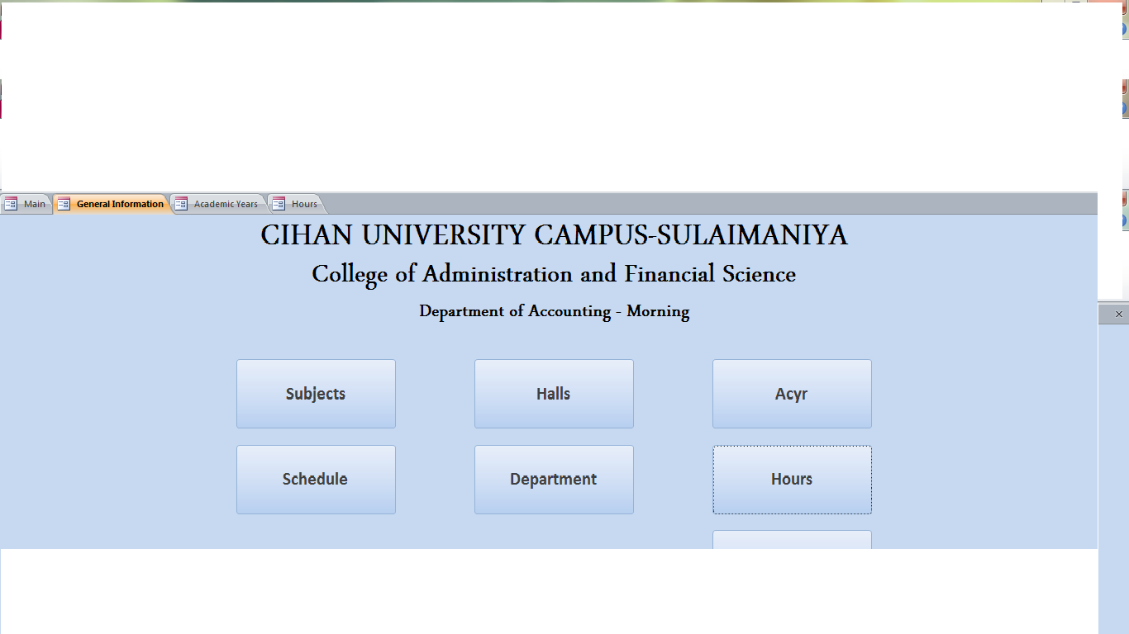
Figure 5
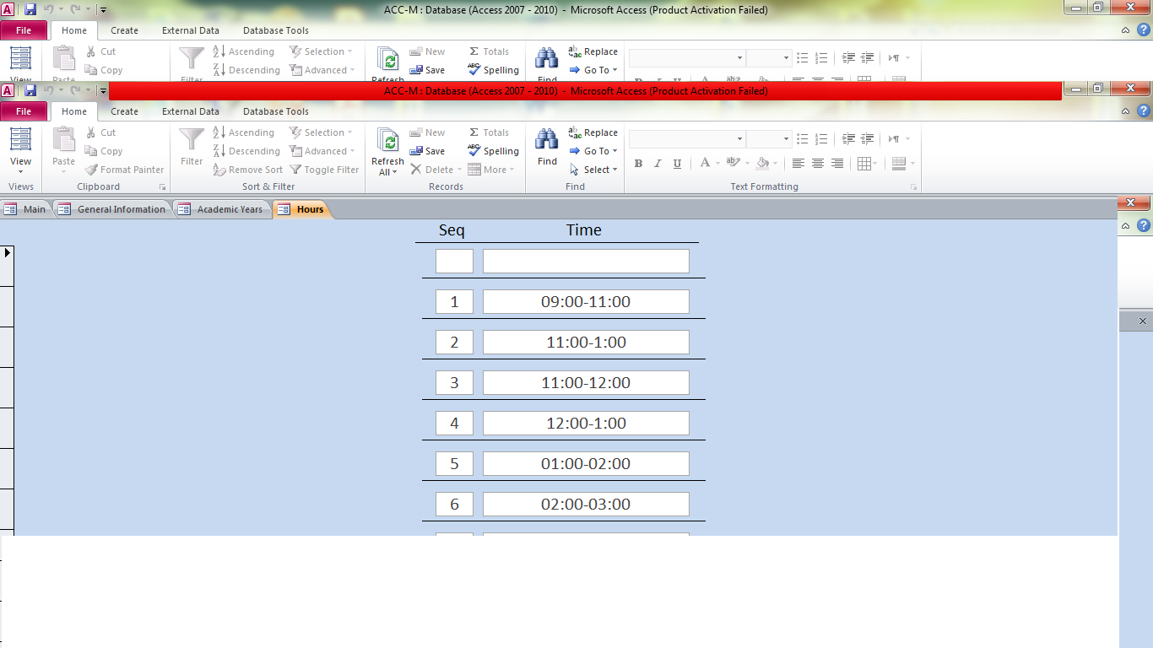
After this page the teacher will get the following page as shown in figure 6

Figure 6
In this page the teacher should write down the hours as its in weekly schedule
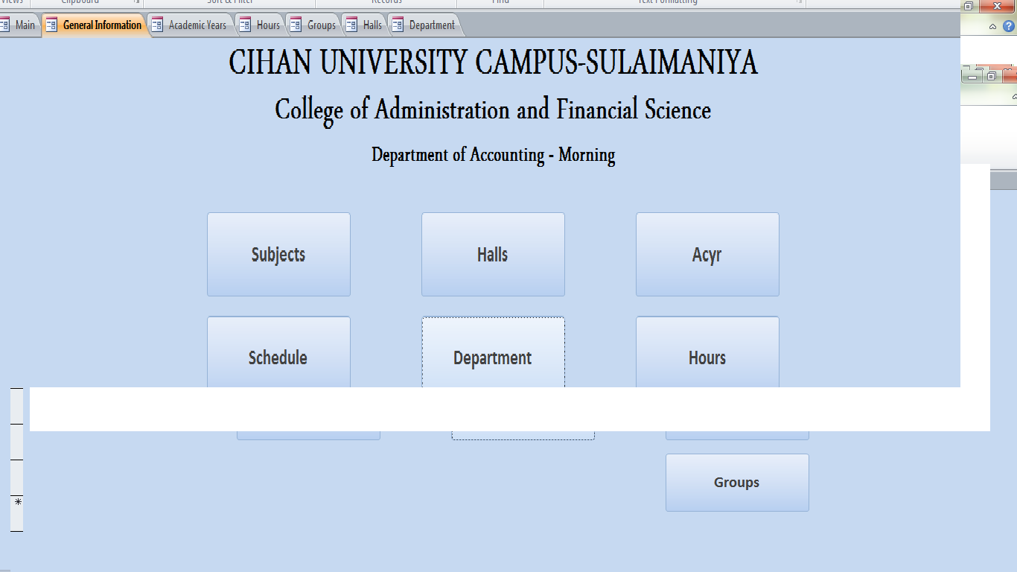
- Then we will go to next tab which is “department” tab which contain information about the department and the lecturer as shown in figure 7 below .
Figure 7
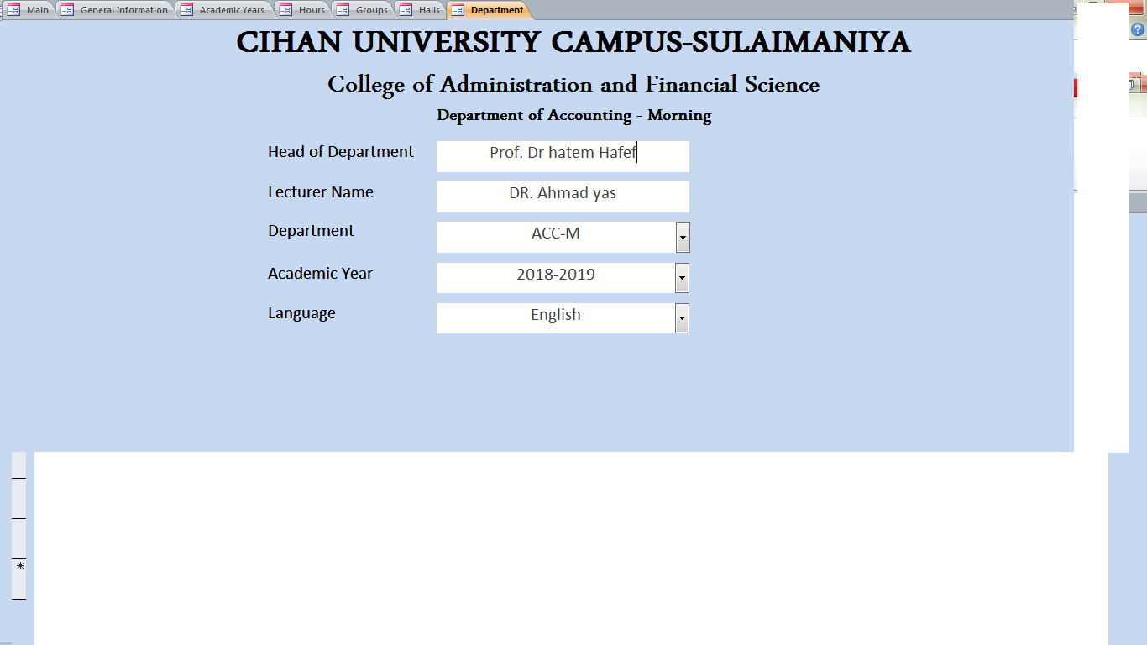
After you clicking on department tab you will get the following page as shown in figure 8.

Figure 8
Its clear that all the information should be entered on by one .
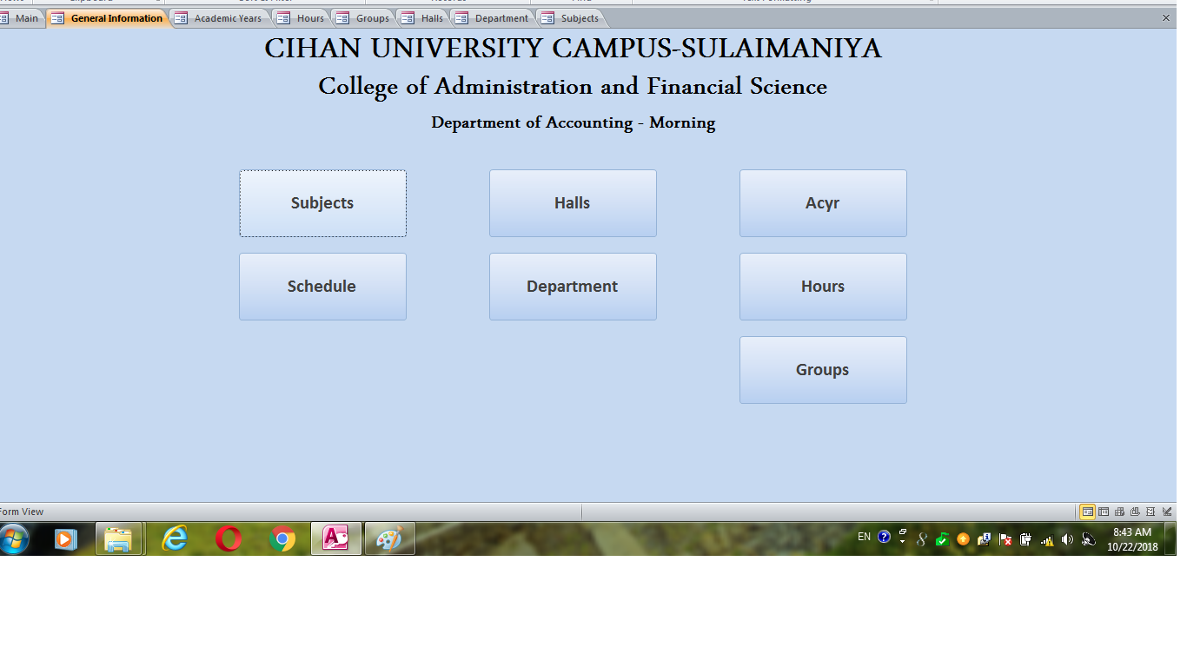
- The we will click on next tab which is “subject” tab as shown in Figure 9.
Figure 9
After we clicking on “subject: tab we will get the following page as shown in figure 10 below .
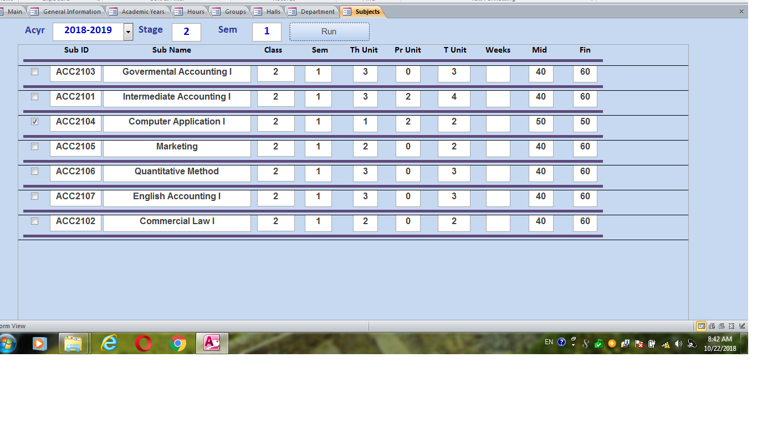
Figure 10
In this page the teacher should specify the academic year , stag, and semester, the press on “run” button , immediately he/she will get all the subject in this stage ,so he need just to select the subject as shown in previous figure.
- Then the teacher will go to next tab which is “schedule” tab as shown in figure 11 below .
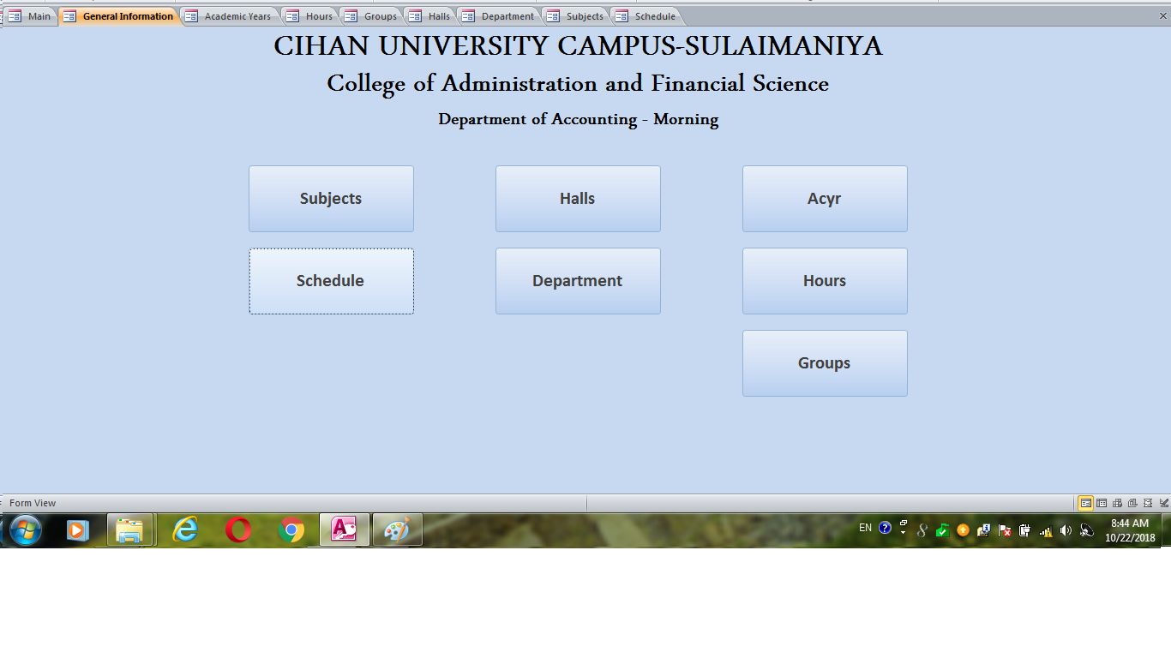
Figure 11
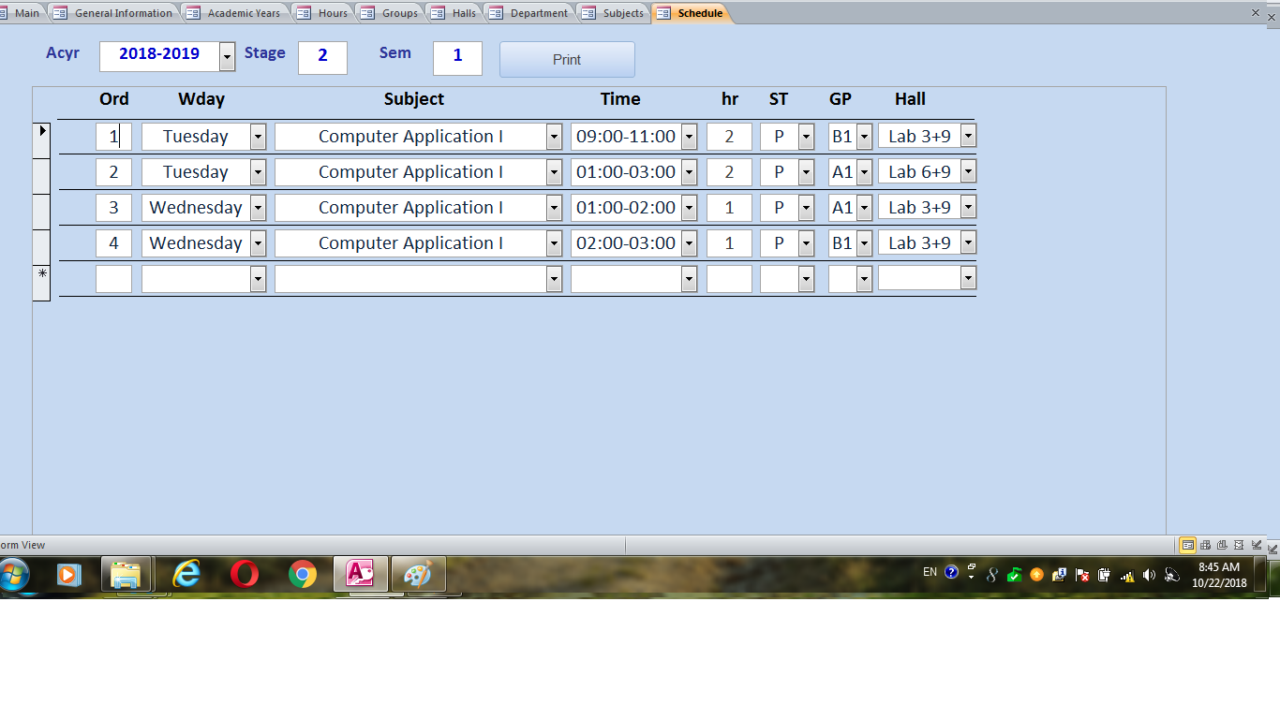
After the teacher clicking on the previous tab he/she will get the following page as shown in figure 12 below.
Figure 12

In this page the teacher should specify at the top of the page Academic year , stage, semester, and start writing in the following fields the order, day of lecture ,subject, time, hours, theoretical hours, practical hours, and hall, one by one until finish all days according to weekly schedule.
Right now all the pages of general information tab finished just need from the teacher to make save all what he did and then go again to the main interface to select “ students” tab, as shown in figure 13 below.
Figure 13
When he/she click on student tab will get the following page as shown in figure 14 below.
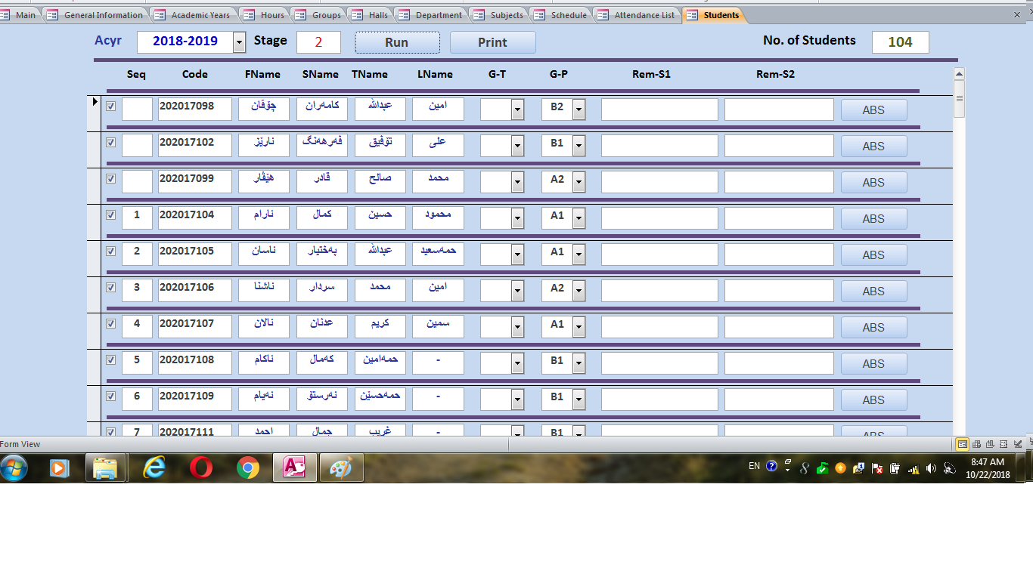
Figure 14
In this page he/she will page he/she need to specify the academic year and the stage in the top of the page and press the “run “ button” immediately he/she will get the list of all student in the stage , here need to specify for each student the group where he/she is and make save the page and exit to main interface.

- In main interface need to click on “ Attendance List” as shown in figure 15 to activate the attendance list for each lecture you have in weekly schedule .

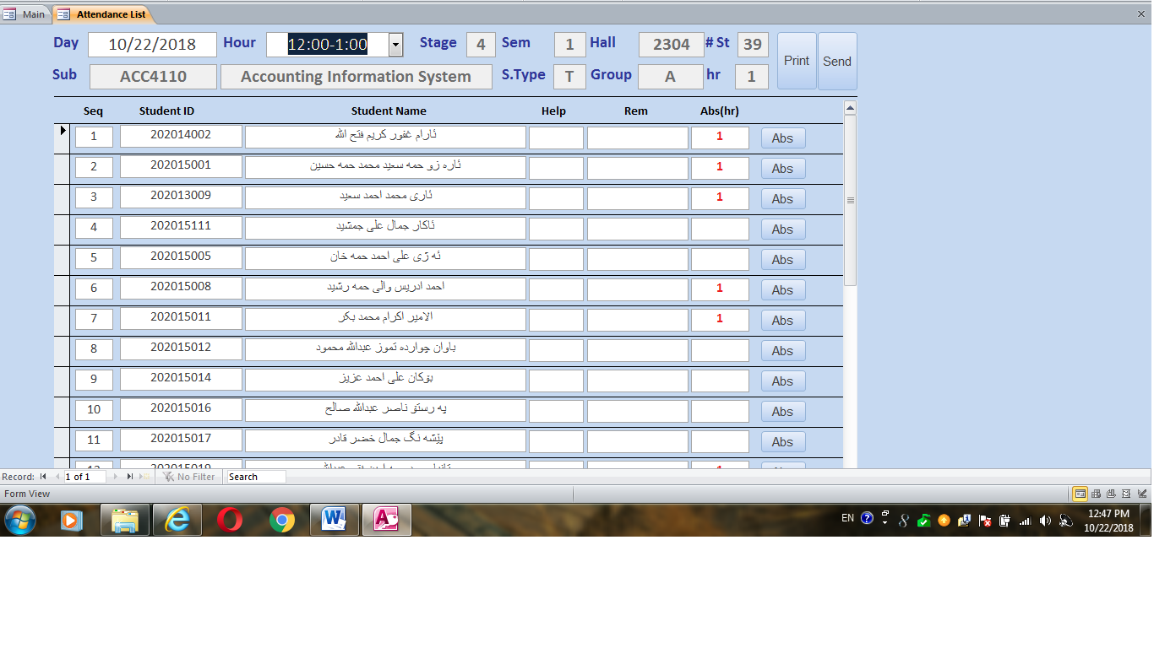

Figure 15
In this page he/she need daily for each lecture specify at tope of page (date of lecture, hour of lecture, stage, semester) immediately you will get a list of all students and you can register the absent students by writing 1 , or 2 in field (Abd(hr)) , then save the page and press “send” button .
- The final tab is “Mid term “ which is used to register the marks of students, as shown in figure 16.

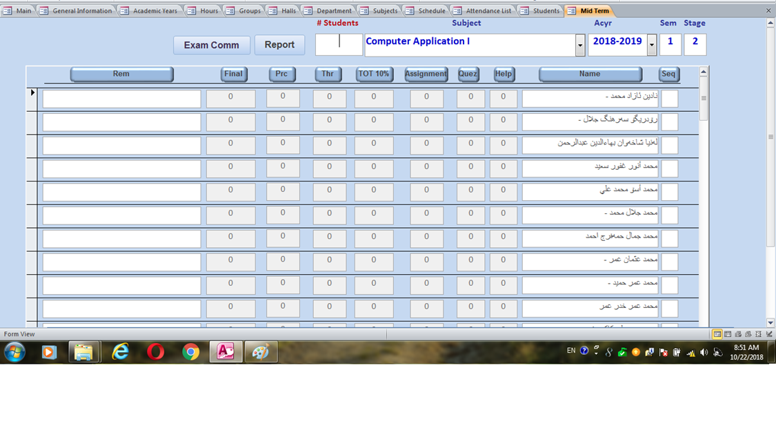
Figure 16
In this page he/she need to specify the (academic year, stage, semester, and the subject) immediately you will get the students list to register the marks according to the constrains of exam committee.

Dr. Ahmed Yass
22/10/2018

